# Software Requirements

1. Introduction
   1. Purpose

The purpose of this document is to present a detailed description of Fuel and Cost Calculator application (hereinafter called Calculator, Just Monitor or simply Project). It will explain some of the key features at very high level.

* 1. Scope

The document will cover the basic functionality on high level regarding the Just Monitor. The user-management system, which is over there to add some more features for registered users. The filter section for selecting car model. The details page for each specific car model that is part of our database.

1. Overall description
   1. System environment   
      The Project has **two active actors**, **normal user and registered user.** All of them are accessing their parts from the internet. The Unregistered user can access **the basic functionality** of the project. It can **view products, categories and pictures rate and compare products as well.** The Registered user can access some of the basic CRUD operations over the orders. It can add new car models, edit current models, add and remove details from it.
   2. Design
      1. **Pages** should contain Header and Footer, which need to be equal for each page

* Header should contain Register and Login links, which navigates to new page, where users can complete these operations. It also need to have About link, which redirect user to new page, where he can find information about Project.
* Footer should say that all rights for this site are reserved by our company. Also it has to contain link, which redirect to page with information about creators of the Just Monitor.
  + 1. **Home page** should have short description of the Project and its main functionalities. Possibility for simple selection for car brand selection or even for specific car. Body also have to have 4 links for getting top 30 car models in some categories for most economic vehicles (diesel, gasoline, LPG, CNG)

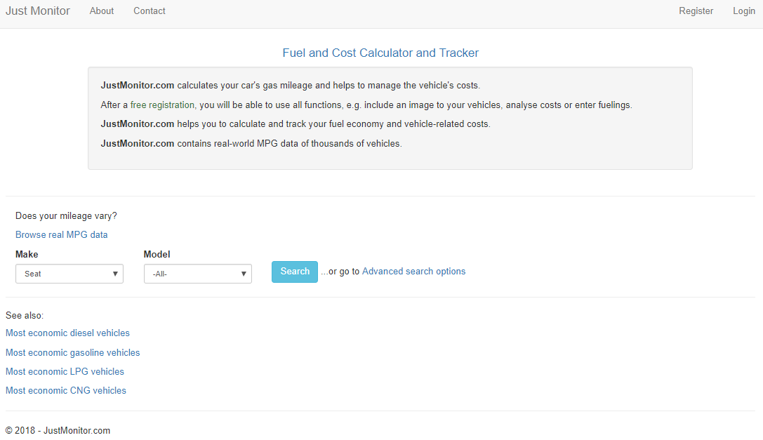

* + 1. **Register/Login pages** Both pages need to be very simple and provide basic functionalities.
* Register page must have button for registration, which to be active after user add some information in all 4 necessary fields:

1. 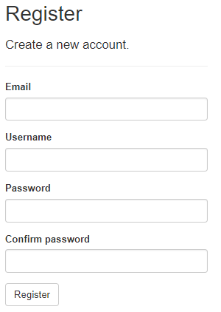Email
2. Username
3. Password
4. Confirm password

* **Login page** should have basic functionality for Login by providing user name and password. We need to integrate our site with Facebook and Google APIs, so we can provide possibility for our user to login in with their Facebook or Google account. There should be buttons, which redirect to right platform to login in it.

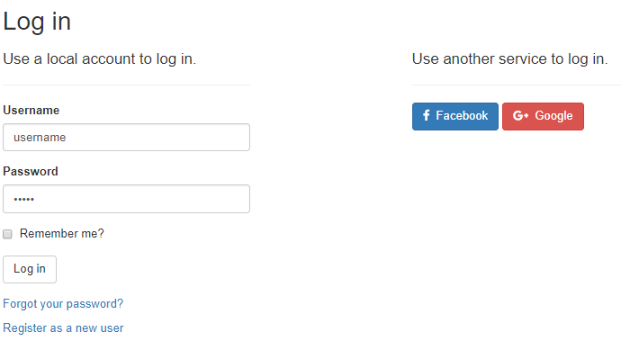

* + 1. **Search page** should provide a lot of criteria for filtering brands and models of cars. All filters should be placed on the left part of the page and on the right the right part have to be shown all results of filtering. There will be 11 criteria for filtering cars:
    - Make
    - Model
    - Exact Model Name
    - Vehicle Type
    - Gearing Type
    - Fuel Type
    - Year From
    - Year To
    - Power From
    - Power To
    - Minimum Kilometers

Each time when Search button is click, on the right side must be shown all models that have these properties. All results should have 5 different properties:

* + - Image (visible only for registered users)
    - Vehicle
    - Consumption
    - Owner
    - Actions (available only for registered users)

Search section will be peggable, so if there are many results on the bottom of the page should be displayed button for First page, Prev. page, Number of page, Next page, Last page. This button should not be displayed if there are less results for current search.

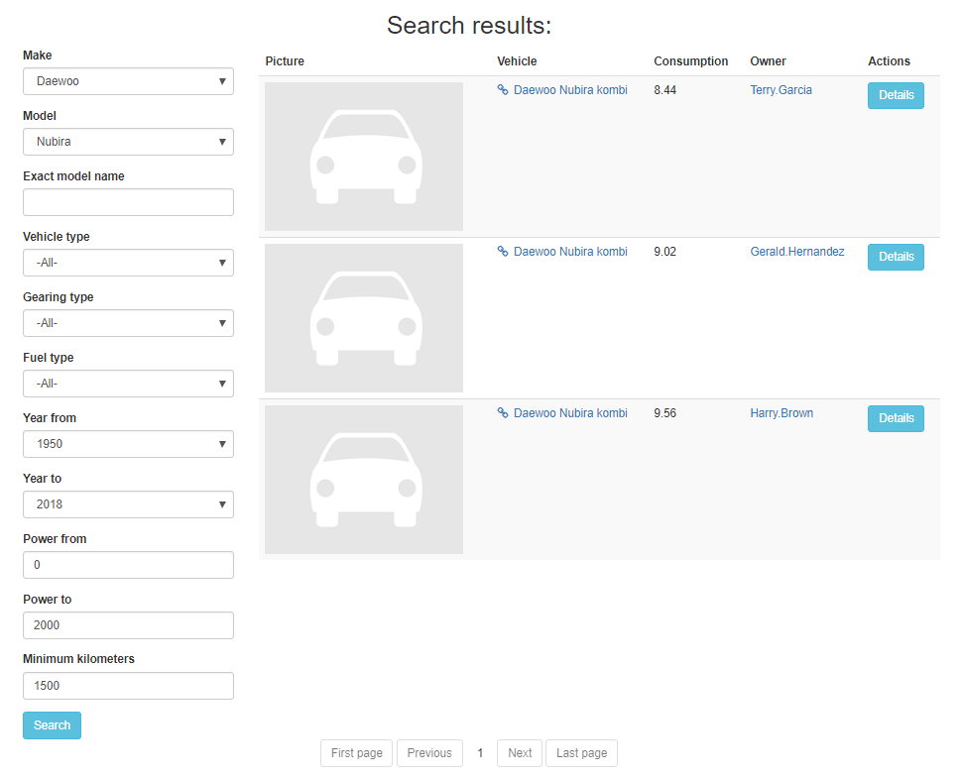

* + 1. **Details page** should be accessed only by registered users. In it we can see some sections.

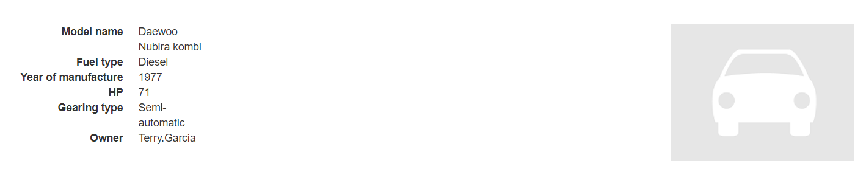

Below Details section we need to have 2 diagrams (Route Profile and Consumption histogram)

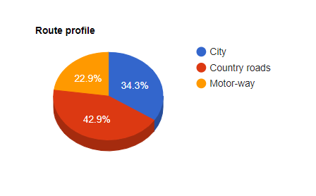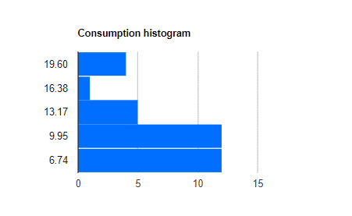

Below we have to see section with statistics

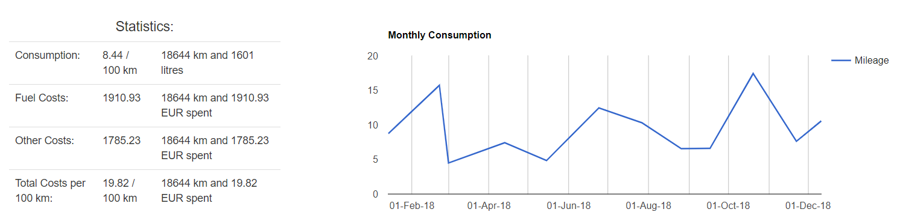

On the bottom of Details page user can find section with all Entries for current car. Each entry has 10 properties:

* + - Date
    - Odometer
    - Trip Odometer
    - Destination
    - Quantity
    - Fuel
    - Price (USD)
    - Average
    - Type
    - Options
    1. **Top cars page** should have section with all top 30 ordered car models by their stats. Below this section user can find link, which download excel file with all top 30 ordered car models Only registered users can download excel file.
  1. Functional requirement specification

* + 1. Use Case 1 (Accessing the system)

The system is accessed through the internet from its initial URL. It loads header, navigation bar and a home page.

* + 1. Use Case 2 (Navigation bar)

The navigation bar has navigational hyperlinks to the Register and Login. When user is successfully Log in, this link has to change to {username} page (My Account page).

* + - 1. Navigation bar – Login with username

When user fill valid user name and password, he/she should be logged in the system. After successful log in user have to be redirected to Home page.

* + - 1. Navigation bar – Login with third-party API

When user click on third-party icons (Facebook and Google), new windows need to pop-up, where connection with third-party API is confirmed.

* + - 1. Navigation bar – Register

When the visitor is unregistered, this hyperlink navigates to the Register page. After filling the right data in every field user should be informed that he/she receive mail in his mail box for confirmation of registration. This link has to navigate to Home page, where user is automatically logged in for the first time.

* + - 1. Navigation bar – About

When user click on About link, new page should be loaded, where user can see basic description of project

* + 1. Use Case 3 (Home page)

User can do some action on Home page. He can do simple search by providing brand and model of the car. After clicking "search" button, user should be redirected to search page.  
If user is logged in he can see links for top 30 for some categories of cars.

* + 1. Use Case 4 (Search page)

On page user can see results of his search on the right side. On the left user can see all criteria for searching in Just Monitor. User can **change his/her search at any time** by setting new values in any or all criteria from the left bar. There will be 11 criteria:

* + - 1. **Make** criteria should contain all of brands that we will support in Just Monitor
* Alfa Romeo
* Audi
* Chevrolet
* Chrysler
* Citroën
* Daewoo
* Dodge
* Fiat
* Ford
* Honda
* Jaguar
* Jeep
* Kia
* Mazda
* Mercedes-Benz
* Mitsubishi
* Opel
* Porsche
* Rover
* Seat
* Smart
* Subaru
* Volkswagen
* Volvo
  + - 1. **Model** criteria should show all models for selected brand
      2. **Exact Model Name** have to be input field, where user can fill text and look for concrete model, if he/she know exact model name
      3. **Vehicle type -** dropdown with all supported types of vehicle
* Car
* Motors
* Bus
* Truck
* Other
  + - 1. **Gearing Type** **-** dropdown with all supported gearing types for vehicles
* Automatic
* Manual
* Continuously variable
* Direct shift gearbox
* Semi-automatic
  + - 1. **Fuel type** **-** dropdown with all supported fuel types for vehicles
* CNG
* Diesel
* Vegetable Oil
* Bio Diesel
* Electricity
* Gasoline
* Hydrogen
* LPG
  + - 1. **Year from / Year to** - dropdown with all years after 1950
      2. **Power from / Power to** - field boxes for only positive values of vehicles horse power
      3. **Minimum Kilometers** - field box for only positive numbers, which represent current vehicle driven distance
    1. Use Case 6 (Details page)

Only registered users can access this page.   
First one should contains details for the car (Model name, Fuel type, Year of manufacture, Horse Power, Gearing type, Owner) and picture of the car.

Second section is chart section, where user can find Route profile and Consumption histogram.

Third section is statistics, where we can find information about (Consumption, Fuel Costs, Other Costs, Total Costs per 100 km). Also user have to see Monthly Consumption for selected year. This Monthly Consumption will be visualizing in form of chart. On top of chart user can selected one of all possible years for which our system has statistics.

Forth section have to have entries for each vehicle in our system. Here user can find info for every single time when current car is driven. Every car can have **many** entries, so this section need to be peggable and need to show only 20 entries by page. On the bottom of the section we can find current loaded page and buttons for first page, previous page, next page, last page.

* + 1. Use Case 7 (Top cars page)

On this page user can see top cars in selected category. Registered users can find even link for download excel file with current ranking